ATTACHMENT J-12

Sample Task Order (STO) #3 – BASE COMMUNICATIONS NETWORK FOR OUARGLA, ALGERIA

Introduction

The U.S. Government Organization (USGO) requires a complete solution for base communications in Ouargla, Algeria. The solution will be Government-owned contractor-operated. There are 42 buildings, of which 40 are located within a four (4) square mile area in the center of the base. The base is approximately (5 mi x 5 mi) 25 square miles. The base serves approximately 1,000 personnel stationed in the Sahara Desert and communications services are required for all buildings on the base. All buildings are wired with 120V electrical outlets and those with Internet access requirements are wired with CAT V cable jacks. All barracks and private residences are wired with RJ-11 telephone jacks.

Objective

The objective is to obtain a complex SATCOM solution that provides base communications meeting the objectives described in this STO. Included is engineering support, system design; hardware procurement, installation, integration, and testing; communications services; logistics support; and program management. The overall objective is for the Offeror to design, test, implement, operate and maintain a total solution that provides reliable communications for all personnel and units at the operating base at Ouargla, Algeria at the most affordable cost to the Government.

Summary of Requirements

The Offeror shall propose a solution compliant with all sample task order requirements that delivers the required quality of service and availability and articulates rationale for the choice of architecture and components, including life cycle cost considerations.

Services to be provided include:

- System design
- System Architecture and Documentation
- Integration
- Testing
- System Engineering
- On-going maintenance and operational support services
- Customer care and help desk support
- Telephone Service
- Wireless High-speed Internet service
- Cellular telephone service
- Wired LAN, Internet, local and long-distance telephone service
- Point of Sale (POS) Service
- Individual Billing Services for Internet and telephone service
- Satellite connectivity to the military base

Management Requirements

3.1.1 The Offeror shall provide a detailed project schedule (e.g., Microsoft Project or equivalent) in PDF format for the entire Task Order lifecycle.

3.1.2 The Offeror shall discuss:

The roles and responsibilities of the Offeror and Subcontractors that will contribute to the solution, how work will be partitioned among subcontractors (if applicable) and how subcontractors will be managed.

Procedures to ensure establishment and maintenance of the logical and physical enclaves of voice and data services (NIPRNET) and secure voice and data (SIPRNET) to avoid spillage from the SIPRNET onto the NIPRNET.

An approach for the implementation of a web portal to present the health of the entire solution in a consolidated view.

Program management approach, procedures, and performance metrics and provide an explanation of how they will be used to ensure timely system development, installation and operation.

Processes and procedures to comply with all U.S. and Algerian environmental regulations prior to and during installation of telecommunications infrastructure (e.g., satellite terminal).

Identification and assessment of risks and a mitigation strategy that minimizes cost, schedule, and performance risk.

Management procedures to ensure network quality of service is not diminished during peak usage of wireless hotspots.

Implementation of a process to deliver timely and accurate invoicing for individual Internet and phone services.

Process and procedures required to develop and furnish the deliverables in Section 7.2.

Technical Requirements

3.2.1 System Engineering

3.2.1.1 The Offeror shall develop and document the requisite communications infrastructure to meet the requirements.

3.2.1.2 The Offeror shall discuss how the design of the network and network components incorporates physical and logical hardening to withstand the rigors of the Sahara Desert conditions (e.g., extreme temperatures, haboob, etc.).

3.2.1.3 The Offeror shall explain the rationale for the proposed network and components, including lifecycle cost considerations. The Offeror shall discuss how lessons learned from previous projects were incorporated.

3.2.1.4 The Offeror shall clearly explain their recommendation for bandwidth, stating assumptions, to ensure that only the necessary amount of bandwidth is leased. The Offeror shall implement configuration management, prepare engineering documents and reference manuals, and provide engineering and testing services.

3.2.1.5 The Offeror shall identify valid installation challenges and risks (excluding any items provided Government Furnished Equipment (GFE)), and provide realistic mitigation for each.

3.2.1.6 The Offeror shall discuss how their system incorporates reliability, availability, maintainability, security, network monitoring and interoperability.

3.2.1.7 The Offeror shall address system flexibility and optimization, accommodating potential future needs to support either new sites or higher per-site data transfer needs or spectral optimization to minimize bandwidth needs.

3.2.2 System Design

The Offeror shall design a system that:

3.2.2.1 Is a closed network with no connection to Algerian telecommunications infrastructure.

3.2.2.2 Provides connectivity to a shared US Government Gateway that can deliver voice and data services (NIPRNET) and secure voice

and data (SIPRNET). The Offeror must provide logically segregated networks for required NIPRNET and SIPRNET access. The physical separation of the NIPRNET and SIPRNET will be in accordance with Chairman of the Joint Chiefs of Staff Instruction (CJCSI) 6211.02D, Defense Information Systems Network (DISN) Responsibilities.

Meets the required quality of service for high-speed Internet service, Voice over Internet Protocol (VoIP), video teleconferencing, and PoS, and meets or exceeds a system availability of 99.8% given the environmental conditions in the Sahara Desert.

Is scalable and allows for new technology insertion.

Provides a level of security appropriate for the level of information that will be processed.

3.2.3. The Offeror should provide a description of the system and network diagrams that demonstrate connectivity between all required structures on the base to include physical and wireless connections, and access points for Government review/approval.

3.2.4 The Offeror shall develop a test plan for the network and provide it to the Government for review/approval no later than 30 days after award. The Government reserves the right to attend all tests. The Offeror shall provide completed test reports to the Government within ten (10) days of test completion. This will be a post-award contract deliverable. See Section L.22.2 regarding submission of post-award contract deliverables.

3.2.5 All equipment delivered as part of the complex satellite solution shall be new equipment.

3.2.5.1 The Offeror shall provide all original manufacturer equipment documentation.

3.2.5.2 The Offeror shall provide as-built drawings for all equipment installations. This will be a post-award contract deliverable. See Section L.22.2 regarding submission of post-award contract deliverables.

3.2.5.3 The Offeror shall provide software configurations for all equipment. This will be a post-award contract deliverable. See Section L.22.2 regarding submission of post-award contract deliverables.

3.2.6 Infrastructure and Communication Services Requirements

3.2.6.1 The high-speed Internet Quality of Service minimum requirement is 128 kbps per computer on the network.

3.2.6.2 The VoIP Quality of Service minimum requirement is 32 kbps per VoIP phone.

3.2.6.3 The video teleconferencing Quality of Service minimum requirement is 128 kbps per conference room.

3.2.6.4 The PoS Quality of Service minimum requirement is a rapid (4-6 seconds) satellite transmission of data, voice and video to and from PoS locations on the base to a credit card network for authorization of a transaction.

3.2.6.5 The cellular telephone service minimum requirement is measured by the grade of service (GoS), which measures the ratio of unsuccessful calls to total calls attempted. For the cellular circuit, the minimum requirement for the GoS is 0.02. This means that two users of the circuit group out of a hundred will encounter a call refusal during peak traffic periods.

3.2.6.6 The Offeror shall provide all infrastructure and communications services requirements to support wired and wireless Internet, VoIP, telephone, video teleconference, and PoS service as described in Table 1 below. The Offeror shall ensure that the VoIP telephones are compatible with the VoIP service.

Table 1. Infrastructure and Communications Services Requirements
Building | Description | Qty | Communication Service Requirement
Offices  (A) | Two-Story building; 100 desks per building;  10 conference rooms per building | 5 | - Wired Local Area Network (LAN) with high-speed Internet access for offices in each building  - The LAN shall also provide VoIP telephone service with voicemail.  - 100 individual desks per building, each require a computer and telephone  - 10 conference rooms per building that provide 12 wired LAN ports each and must support video teleconferences
Junior Enlisted Barracks (B) | Two-Story building; 100 private rooms occupied by two persons; two phones per room | 5 | - High-speed wired Internet access (Individual billing for private high-speed Internet service)  - Local and long-distance telephone service (Individual billing for telephone service)
Senior Enlisted Barracks (D) | Two-Story building; 50 private rooms occupied by one person; one phone per room | 1 | - High-speed wired Internet access (Individual billing for private high-speed Internet service)  - Local and long-distance telephone service (Individual billing for telephone service)
Officers Billeting (E) | One-Story building; 30 private rooms occupied by one person; one phone per room | 1 | - High-speed wired Internet access (Individual billing for private high-speed Internet service)  - Local and long-distance telephone service (Individual billing for telephone service)
Private Residences  (F) | One-Story | 10 | - High-speed wired Internet access (Individual billing for private high-speed Internet service)  - Local and long-distance telephone service (Individual billing for telephone service)
Communications Center (G) | One-Story | 1 | - High-speed wired Internet access  - Local and long-distance telephone service  - Secure voice and data service
Base Headquarters (H) | One-Story | 1 | - High-speed wired Internet access  - Local and long-distance telephone service  - Secure voice and data service
Supply Warehouse (I) | One-Story | 2 | - High-speed wired Internet access  - Local telephone service
Armory (J) | One-Story | 1 | - High-speed wired Internet access  - Local telephone service
Maintenance Facilities (K) | One-Story | 3 | - High-speed wired Internet access  - Local and long-distance telephone service
Commissary (L) | One-Story | 1 | - High-speed wired Internet access  - Local and long-distance telephone service  - Secure service for credit card transaction processing at 12 point of sale (PoS) terminals
Gas Station (M) | One-Story | 1 | - Local and long-distance telephone service  - Secure service for credit card transaction processing at 6 point of sale (PoS) terminals
Base Exchange (N) | One-Story | 1 | - High-speed wired Internet access  - Local and long-distance telephone service  - Secure service for credit card transaction processing at 12 point of sale (PoS) terminals  - High-speed wireless Internet access hotspot*
MWR Facility (O) | Two-Story | 1 | - High-speed wired Internet access  - Local and long-distance telephone service  - Secure service for credit card transaction processing at 4 point of sale (PoS) terminals  - High-speed wireless Internet access hotspot*
Base Dining Facility (P) | One-Story | 1 | - High-speed wired Internet access  - Local and long-distance telephone service  - High-speed wireless Internet access hotspot*
Base Library (Q) | One-Story | 1 | - High-speed wired Internet access  - Local and long-distance telephone service  - High-speed wireless Internet access hotspot*
Base Security (R) | One-Story | 1 | - High-speed wired Internet access  - Local and long-distance telephone service  - Secure voice and data service
Base Fire Department (S) | One-Story | 1 | - High-speed wired Internet access  - Local and long-distance telephone service
Base Medical Facility (T) | One-Story | 1 | - High-speed wired Internet access  - Local and long-distance telephone service
Base Chapel (U) | One-Story | 1 | - High-speed wired Internet access  - Local and long-distance telephone service
Base Entrance Facility (V) | One-Story | 2 | - High-speed wired Internet access  - Local and long-distance telephone service

* Peak usage for each wireless hotspot can be expected to reach 200 connections

Additional Infrastructure and Services Requirements

3.2.7.1 The Offeror shall provide all Internet access through a U.S. based Internet Point of Presence (PoP). For example, users should reach google.com and not google.dz

The Offeror shall provide cellular telephone service with a service coverage area of the operating base in Ouargla, Algeria.

The Offeror shall provide individual billing and operator assistance service for long-distance calling.

3.2.8 Lifecycle Management

3.2.8.1 The Offeror shall present an approach for lifecycle management (on-going maintenance and operational support services, customer care and help desk support to include electromagnetic interference (EMI)/radio frequency interference (RFI) resolution support. The Offeror shall provide a logistics support plan that maximizes use of standard commercial off the shelf equipment, interoperable components, and minimizes numbers and types of spares. The plan shall address inventory management, and maintenance planning, to include the approach to minimize the mean time between failure and mean time to repair. This will be a post-award contract deliverable. See Section L.22.2 regarding submission of post-award contract deliverables.

The managed network services shall include space segment, teleport, and terrestrial components as necessary to ensure a complete end-to-end communications solution.

Space segment coverage is only required for Algeria.

Space segment shall meet 99.999% availability. The satellite gateway shall meet 99.95% availability per year.

The Offeror shall develop and provide network architecture and configuration documentation, link budgets, and transmission plans. The Offeror shall provide maps with clearly depicted and labeled contour lines, demonstrating coverage across the required locations. Contour lines should clearly demonstrate satellite gain to noise temperature ratio (G/T), effective isotropic radiated power (EIRP), and elevation angle values for proposed satellite(s) and covered region.

The Offeror shall have a means of satellite communications electromagnetic interference (EMI) and radio frequency interference (RFI) identification, characterization, and geo-location. The Offeror will be required to analyze and report all EMI/RFI to the Government and may be asked to participate in exercises involving EMI/RFI.

The Offeror will be required to meet Federal and DoD Information Assurance requirements for a Moderate Impact Information System. The Offeror shall provide a completed Information Assurance (IA) checklist (Attachment J-2).

3.2.9 Frequency Clearances and Approvals

3.2.9.1 The Offeror shall describe the frequency clearance requirements and explain how the requirements will be met to allow transmission in Host Nations. The Offeror shall support Host Nation Agreement (HNA) efforts in obtaining international approvals for radio spectrum operations under this contract in foreign nations. The Offeror shall ensure that international services provided under this contract may be provided as scheduled with the full approval of each affected host nation. Typical services may include, but are not limited to: host nation approvals, landing rights, operating agreements, site licenses, and frequency clearances.

3.2.9.2 If additional host nation support becomes necessary during the life of the task order, contract line item numbers will be added to the order at the time they are required and shall be invoiced at pass-through rates. The Offeror may be required to provide HNAs for any nation covered within the limits defined in the coverage area, as needed by the user.

3.2.9.3 Frequency Clearances shall be requested for the maximum time period allowed by the host nation, up to the life of the contract.

3.2.9.4 The Offeror shall provide the Government with copies of regulatory licenses and approvals obtained to operate and use the spectrum for countries within the required service region.

3.2.10 Network Monitoring

3.2.10.1 The Offeror shall staff a 24/7/365 Network Operations Center (NOC) as a focal point for network access, technical support, and troubleshooting. NOC staff shall be English-speaking and U.S. citizens.

3.2.10.2 The Offeror shall be required to coordinate with external offices and agencies, USGO Operations Centers, and other communications planners, managers and operators. The Offeror shall describe procedures for coordination with external offices and agencies, USGO Operations Centers, and other communications planners, managers and operators.

3.2.10.3 The Offeror shall provide status reporting on equipment status, network status, and network utilization. The Offeror shall create and manage trouble tickets. The Offeror shall produce monthly and annual resource utilization reports. These will be post-award contract deliverables. See Section L.22.2 regarding submission of post-award contract deliverables.

3.2.10.4 The Offeror shall establish, and provide the U.S. Government access to a web portal to present the health of the entire solution in a consolidated view using data from multiple sources. The U.S. Government prefers the capability to receive fault/incident/outage reports (e.g., interference, anomalies) in an automated way, vice a trouble ticket from an operations center.

3.2.11 Additional Requirements

3.2.11.1 The Offeror shall provide all required software and firmware for all contractor furnished equipment to include Windows Operating System for the laptops. This will be a post-award contract deliverable. See Section L.22.2 regarding submission of post-award contract deliverables. The Offeror shall be responsible for system administration, maintaining back-ups/restoral capability, firewall management, and system security to include maintaining IA compliance.

3.2.11.2 The Offeror will provide an unpriced Bill of Materials (BOM) in Microsoft Excel that will include services, equipment, and labor (Attachment J-13).

Performance

Locations

Work is to be performed at Government facilities. Equipment shall be shipped to the USGO location in Algeria. Technical support for operations and maintenance will be required at the USGO location in Algeria.

Period of Performance

The period of performance for this Task Order will be five (5) years.

In the first six (6) months after contract award, the Offeror shall acquire, integrate, test, and deliver the requested capability.

Government Support

Government Furnished Equipment/Facilities

The Government will provide contractor workspace in Maintenance Facility Building K.

The Offeror shall identify the number and type of High Assurance Internet Protocol Encryption (HAIPE) network encryption devices that the Government needs to procure. Devices will be integrated by the Offeror.

Security

The Offeror shall articulate processes and procedures to address the security requirements for personnel assigned to the task order.

Offeror personnel will be required to have Government authorization, a U.S. SECRET clearance, a U.S. Government-issued Common Access Card, an approved Visitor Authorization Request to access the USGO facility in Ouargla, Algeria, and meet the applicable U.S. Africa Command Reporting Instructions requirements prior to travelling.

All Offeror personnel with access to key operational security information (e.g., unit locations, troop movement information) and key personnel (e.g., Program Manager) shall possess United States SECRET security clearances.

The Offeror shall ensure that all sensitive and classified information is safeguarded in accordance with the guidance provided in the CS3 DD254. Although the Offeror may be provided access to SECRET information in order to accomplish tasks, documents generated shall not include classified information unless directed by the Government and in accordance with classification guidelines and standards for documentation.

Deliverables

Pre-Award Deliverables (Submitted with Offeror’s Proposal)

The following deliverables will be used to document the comprehensiveness of the Offeror’s complex satellite solution for the Base Communications Network for Ouargla, Algeria.

- IA Checklist (Attachment J-2)
- Link Budget
- Original Manufacturer Equipment Documentation for Each Terminal Suite
- Network Architecture and Configuration Documentation, and Transmission Plans
- Maps with clearly depicted and labeled contour lines, demonstrating coverage across the required locations. Contour lines should clearly demonstrate satellite gain to noise temperature ratio (G/T), effective isotropic radiated power (EIRP), and elevation angle values for proposed satellite(s) and covered region
- Bill of Materials
- Schedule

Post-Award Deliverables

In the STO Task Order Management Plan, the Offeror shall describe the process and procedures they will employ to develop and furnish the below listed deliverables for this Task Order. This will be a post-award contract deliverable. Please see Section L.22.2 regarding submission of post-award contract deliverables. Other post-award contract deliverables include the following:

- Task Order Management Plan
- Test Plan
- Logistics Support Plan
- HNA Frequency Clearances, Regulatory Licenses and Approvals
- As-built Drawings
- Software Configurations
- Status Reports
- All required software and firmware for Offeror furnished equipment to include Windows Operating System for the laptops.

Pricing

The Offeror is not required to provide any pricing for this Task Order at this time.

U.S, Base Ouargla, Algeria Diagram
The below diagram depicts the structures requiring services. There are 42 buildings, of which 40 are located within a 4 square mile area in the center of the base. The base is approximately (5 mi x 5 mi) 25 square miles. The base entrances are approximately 1.5 miles from the center of the base. There is no current infrastructure installed between any of the buildings on the base.

Note: The diagram is not drawn to scale.

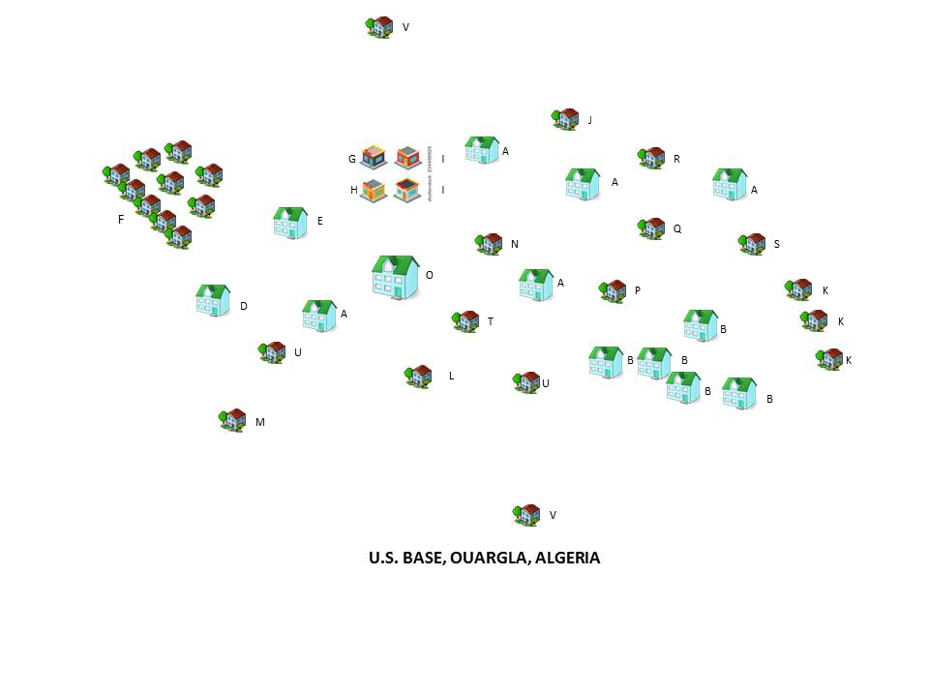

(END OF SECTION J, ATTACHMENT J-12)

